
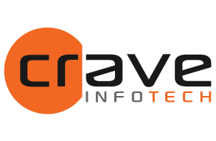

Merck Group RFP Response For

BTP Integration Suite Migration

Submitted on: Nov 12, 2025
Version: 2.0

By:

Crave InfoTech LLC 2035 Lincoln Highway, Suite 3008D
Edison NJ 08817

Point of Contact:

Vishal Verma
Contact: +49 160 90819625
Email : vishal.verma@craveInfoTech.com

Vishal Bargat
Contact: +1 267-306-9374
Email: vishal.bargat@craveInfoTech.com

Contents

Contents 2
- Executive Summary 4
Introduction 4
Awards 5
Diversity Certifications 6
Sustainability 6
Ecovadis Rating for Crave InfoTech 6
Why Crave 7
Alignment with Merck Group’s Integration Vision 7
Crave’s Differentiators - Accelerators and Tools 7
Crave InfoTech’s Experience in Life Sciences 7
Deep Domain Expertise 8
Life Sciences Success Stories 8
Delivery Model and Governance 10
Commitment to Quality, Transparency, and Partnership 10
- Objective 11
Objective 11
- Scope 12
  - Migrating Boomi and SAP PIPO integration 12
  - Out of Scope 13
  - API Management 14
  - Event-based integration with SAP Integration Suite 15
  - Cloud ALM Implementation for Monitoring 16
- Implementation Approach & Timelines 17
- Responsibility Matrix 19
- Project Team 20
Merck Group Team 20
Crave Team 20
- SLAs and Service Credits 21
Service Level Framework 21
Key Performance Indicators (KPIs) 22
Service Credit Framework 22
Exclusions 22
- Change Management 23
- Commercials 24
Development effort estimates calculation 24
We have used following estimates based upon the complexity of the interfaces for the calculation of migration/development efforts 24
Resource Schedule, Rates and Estimated Cost: 24
- Governance (Meetings/Steercos/Escalation Path) 26
Communication Plan 26
Issue Resolution and Escalation Procedure 26
SLA Reporting 28
Service Credit Review 28
Continuous Improvement 28
- Sign Off 29
- Appendix 30

Executive Summary

Introduction:
Crave InfoTech is a trusted SAP Global Partner with a proven track record of delivering Integration Suite modernization and migration programs for Fortune 500 enterprises across the Life Sciences, Retail, and Manufacturing industries. Leveraging deep expertise in SAP BTP, Integration Suite, Edge Integration Cell, and Advanced Event Mesh, Crave InfoTech offers Merck Group a zero-risk, automation-driven, and outcome-focused approach to integration transformation.
Merck Group’s hybrid integration landscape comprising SAP PI/PO and Boomi—requires a unified, scalable, and future-ready integration platform aligned with SAP’s next- generation architecture. Crave’s proprietary Integration Workbench (CIW) and Migration Factory Framework are purpose-built to address such complex modernization initiatives. These accelerators automate assessment, artefact conversion, testing, and validation achieving up to 30% – 40% automation efficiency while ensuring zero business disruption.
Crave InfoTech’s approach has been validated through multiple global success stories:
- Eli Lilly – Migrated from SAP PO to Integration Suite with a 35% reduction in maintenance costs and an API-First strategy.
- Merck USA– Executed phased migration and parallel runs with zero downtime and 40% cost reduction.
- Meijer – Achieved 100% seamless migration and 60% performance improvement through automated interface conversion.
For Merck Group, Crave InfoTech will bring together automation, agile delivery, and intelligent governance using SAP Cloud ALM and CI/CD-based validation pipelines to deliver predictable outcomes and measurable ROI. Our T&M engagement model ensures flexibility, transparency, and close alignment with Merck’s program governance.
With its strong SAP partnership, domain expertise in life sciences, and factory-based delivery model, Crave InfoTech offers Merck Group a reliable, innovative, and proven partner to modernize its hybrid integration ecosystem enabling a future-ready, event- driven, and cloud-native integration platform on SAP BTP.
Crave InfoTech brings a deep and proven expertise in SAP Integration, Migration, and Business Technology Platform (BTP) implementations. Our engagement with SAP as a strategic global partner, combined with decades of experience in delivering digital transformation programs, makes Crave uniquely positioned to support Merck Group in its Integration Suite modernization journey.

Crave InfoTech is pleased to submit a proposal for the BTP Integration Suite Migration. We greatly appreciate the opportunity to present our vision on how Crave InfoTech will enable Merck Group to achieve its stated end-state vision by strategically aligning ourselves to meet Merck’s both immediate and longer-term business objectives.

Crave, a minority and woman-owned organization, is committed to delivering SAP solutions for modern businesses. At Crave InfoTech, innovation is not just a buzzword; it's ingrained in the company's DNA. Our Digital Business Services are positioned to help you build and succeed as an Intelligent Enterprise, accelerating value creation by enabling greater agility, focus, and efficiency.

With our vision to drive innovation, deliver value to customers, and positively impact society, we are passionate about innovation and dedicated to excellence. Crave InfoTech is poised to shape the future of digital transformation. With a steadfast focus on customer satisfaction and a relentless pursuit of technological advancement, Crave InfoTech is a trusted advisor, empowering businesses to thrive in the digital age.
We provide:
- Advisory services for BTP with Keep Core Clean, Future Ready Enterprise (FRE) Assessment, BTP Security & Governance Assessment
- End-to-end process Automation using AI and ML, procure to pay, order to cash & approvals, and workflows
- BTP – integration suite migration, data & analytics, automation, App dev, and monitoring using Cloud Application Life Cycle Management
- SAP EAM offerings along with barcode, QR code, RFID Enablement, AI- powered Predictive Analytics, and Incident Management
- Intelligent Warehouse & Supply Chain – BTP-powered mobile app, smart order picking using augmented reality, proof of delivery, last-mile tracking, MRO warehouse automation, and Transport Management

Awards:




SAP Most Valuable Partner 2024 Inc. 5000 NJ Leaders in Digital Technology



SAP ACE Award 2023 Best Warehouse Fast 100 Asian
Automation & American Business 2024 Software Company 2022

Diversity Certifications





MBE WBE WOSB

Sustainability:

At Crave InfoTech, we recognize the importance of sustainability in fostering long-term growth, innovation, and responsibility. As a leading player in the IT sector, we are committed to integrating sustainable practices into every aspect of our business. The principles of environmental stewardship, social responsibility, and economic viability guide our approach to sustainability.

Currently, Crave InfoTech is part of AstraZeneca’s “Lead In Sustainability” Accelerator
Program to improve our ratings.

Ecovadis Rating for Crave InfoTech

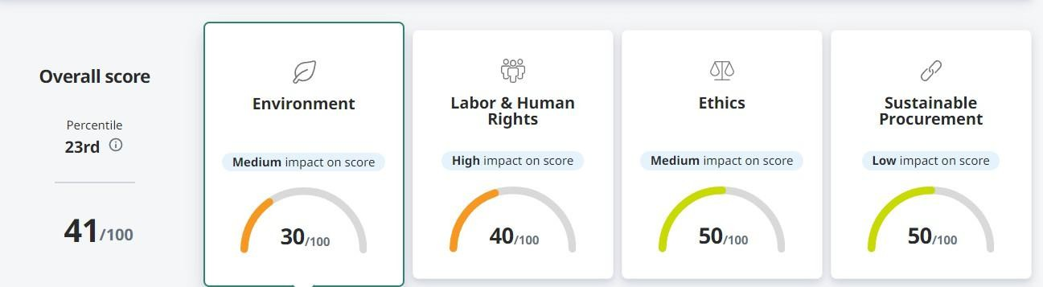

Why Crave

Alignment with Merck Group’s Integration Vision
Merck Group’s strategic direction toward SAP Integration Suite modernization requires a partner who can deliver speed, quality, and governance while managing a hybrid environment. Crave’s approach aligns perfectly with this vision enabling unified integration governance, enhanced automation, and future-ready architecture on SAP BTP.
Our Crave Integration Workbench ensures:
- End-to-end visibility and control over migration waves.
- Automated analysis of PI/PO and Boomi artefacts with conversion to Integration Suite.
- Continuous validation and testing using embedded CI/CD pipelines.
- Full governance integration with SAP Cloud ALM for performance tracking and reporting.

Crave’s Differentiators - Accelerators and Tools
Crave leverages its proprietary accelerators and frameworks to deliver measurable outcomes and ensure repeatability across projects. These tools are built to integrate seamlessly with SAP’s ecosystem while offering advanced automation and traceability.
- Crave Integration Workbench (CIW): Automated Assessment, migration and conversion, validation, and governance of integration artefacts.
- Migration Factory Framework: Repeatable factory model for PI/PO and Boomi migrations.
- Cloud ALM Dashboards: Real-time visibility into KPIs, progress, and risk logs.
- Testing Automation Framework: Automated regression and UAT validation to ensure migration
accuracy.






















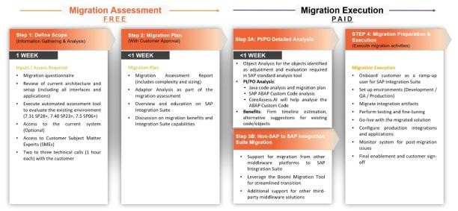
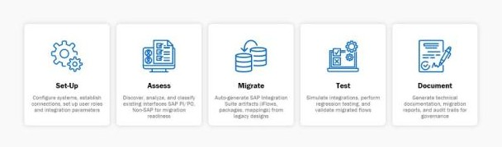
Integration - Migration, Modernization & Consolidation
Crave InfoTech accelerates SAP PI/PO to SAP Integration Suite migration with proprietary tools and automation−driven accelerators, ensuring faster, low−risk transitions for SAP and third−party systems.
Our four−step process, aligned with SAP’s migration factory approach, begins with a free assessment to define scope and build a tailored plan. This is also followed by a paid execution phase covering deep analysis and complete migration, designed for speed, security, and minimal disruption.
Crave Accelerators
Crave InfoTech's accelerators compliment SAP migratory factory tools for better Assessment, Migration, Modernization and Platform Consolidation for SAP PO and other enterprise integration tools.
Significant investment in accelerators for TIBCO, MQ, Biztalk, Web sphere, Web method, Sterling, Boomi and
MuleSoft − SAP cannot create these accelerators for legal reasons.
- ABAP Objects Assessment − API and Events ➢ Migration from Other Middleware to SAP
- Java Mappings Assessment & Migration ➢ Boomi Migration Tool
- UDF & Adapter Modules Migration (In ➢ Additional Middleware Support Development)
- Auto−Generation of post implementation documentation

Proven Success Implementing SAP Integration Suite
Crave InfoTech has completed 50+ integration and modernization projects across industries, ensuring smooth, low-risk transitions.
- Industries Served: Life sciences, oil & gas, chemicals, retail, infrastructure, public sector, food & beverages, and more.
- Interfaces Handled: From 22 to 3700+, covering P2P, R2R, O2C, B2C, CRM, and more business processes.
- Global Reach : Projects delivered in 20 countries across North America, Europe, APAC, MEE, and the Middle East.
- Business Impact: Secure, compliant, and optimized integrations for various business units, ensuring scalability and efficiency.
Integration Workbench
Seamless Platform Consolidation
The Crave Approach: Innovation & Consolidation
Consolidation
Innovation
AI Driven Mappings
We help businesses migrate from
TIBCO, WebMethod, WebSphere, Biztalk, MQ, Boomi, and MuleSoft to SAP Integration Suite by ensuring efficiency, reliability, and a hassle−free transition with our automation−driven tools.
AI based Config. &
Documentation

Support for AI Agents

Event Driven Architecture
Biztalk
SAP INTEGRAT ION SUITE
Edge Integration Cell
Clean Core Integration
NON-SAP TO SAP
SAP TO SAP

Crave InfoTech’s Experience in Life Sciences
11
Crave InfoTech has extensive experience partnering with global Life Sciences enterprises to accelerate digital transformation through SAP Integration Suite, BTP, and Data and Analytics

modernization.

Our solutions have consistently supported the stringent demands of regulated environments, ensuring compliance, traceability, and scalability across R&D, manufacturing, supply chain, and commercial operations.

Deep Domain Expertise
With over a decade of experience in the Life Sciences industry, Crave InfoTech understands the regulatory and operational frameworks governing pharmaceutical and biotechnology companies. Our project teams are well-versed in GxP, FDA 21 CFR Part 11, and data integrity compliance, ensuring every integration and migration meets validation and audit-readiness requirements.

Life Sciences Success Stories

Eli Lilly – Global Pharmaceutical Leader

Migrated from SAP Process Orchestration (PO) to SAP Integration Suite with Crave’s proprietary
Integration Workbench (CIW).
Adopted an API-first and event-driven architecture, ensuring zero downtime and 35% lower maintenance costs.
















Crave also implemented SAP Edge Integration Cell and Advanced Event Mesh, enabling secure, on-premise integrations aligned with GxP compliance.

American Pharmaceutical MNC Migrates from SAP PO to
Success Story

SAP Integration Suite with Crave InfoTech Situation & Goals

Eli Lilly and Company, a global leader in pharmaceutical innovation, is dedicated to creating medicines that improve lives worldwide. As the most valuable drug company in the world, the pharma giant combines cutting−edge research with a strong commitment to addressing unmet medical needs across major therapeutic areas.
  - Pioneer in developing innovative treatments for diabetes, oncology, and immunology.
  - Global presence spanning over 120 countries with a strong focus on accessibility and healthcare advancement.
  - Renowned for integrating science and technology to deliver breakthrough therapies.
  - Committed to sustainability and enhancing global healthcare standards through strategic initiatives and partnerships.
  - Ahead of SAP PO sunset(2027), Eli Lilly wanted to migrate to a new platform for continued support, security, and feature updates for complex process integrations.
  - Needed to ensure continued support, security updates, and a new message broker to replace IBM MQ.
  - Running all interfaces securely on the company’s network without cloud exposure was hindering operational efficiency.
  - Needed a phased migration plan with zero business disruptions was essential to future−proof their IT landscape..

Solution at a Glance
  - Crave InfoTech evaluated Eli Lilly's existing integration environment with Integration Suite's
Migration Tool.
  - Reviewed technical specs and architecture for accuracy.
  - Used Gen AI tools to replace custom code with standard objects.
  - Developed a phased migration plan with prioritized categories.
  - Proposed SAP Integration Suite Edge Cell and Advanced Event Mesh for modernization.
  - Transitioned to API−First and event−driven architectures for efficiency.

Expected Outcomes
  - Simplified integration by consolidating multi−interface processes into single integration flows
  - Enhanced compliance and efficiency with standard APIs and Events over custom IDOCs and Proxies.
  - Future−proof, scalable infrastructure for business growth and IT upgrades.
  - Improved scalability to support business growth and seamless IT upgrades.

Modernization
API-First Strategy
Zero
Disruption & downtime
35%
Reduced Maintenance Costs
Solution BOM:
- SAP Integration Suite − Edge
- Integration Cell
- SAP Advanced Event Mesh
17

Merck – Leading Life Sciences and Technology Enterprise

Collaborated with Merck to modernize its hybrid PI/PO + TIBCO integration landscape and define a migration roadmap to SAP Integration Suite on Cloud Foundry.
The engagement delivered a 40% reduction in integration maintenance cost, full security compliance, and phased cutover for business continuity.











The solution leveraged SAP Alert Notification, Integration Monitoring, and Edge Integration Cell to provide complete visibility and resilience.

Leading Life Sciences Enterprise Migrates from SAP
Success Story

PI/PO to Cloud Integration with Crave InfoTech Our Role

A 350+ year−old global science and technology leader, driving innovation across healthcare, life sciences, and electronics. With operations in over 70 countries, the company continues to shape the future through advanced research, specialty materials, and breakthrough therapies.
This leading enterprise collaborated with Crave InfoTech to assess and modernize its SAP integration landscape. The project began with a detailed analysis of existing SAP PI/PO interfaces and progressed toward a structured migration roadmap for SAP Integration Suite on Cloud Foundry. Additionally, we also delivered a streamlined transition plan that ensured continuity, reduced complexity, and aligned with the client's cloud−first strategy. The engagement laid the groundwork for scalable, future−ready integrations across the enterprise.
Conducting a detailed assessment of the existing TIBCO interface landscape Defining the migration roadmap and cloud integration architecture Executing the re−implementation of all interfaces using SAP BTP Integration Suite Ensuring minimal disruption through phased cutovers and parallel runs Training business and technical teams for self−sufficiency post−go− live

Our Solution
- Migrating of all the interfaces from TIBCO to SAP BTP Integration Suite.
- Designing modular iFlows with centralized error handling and logging.
- Enabling seamless integrations with SAP S/4HANA and external vendors.
- Implementing secure APIs for internal and partner consumption.
- Providing dashboards for real−time monitoring and alerts using SAP Alert Notification and Integration Monitoring

Business Impact
  - Reduction in integration operating costs
  - Faster time−to−market for new business processes and partner onboarding Improved system availability and real−time data exchange across functions Future−ready foundation for event−driven integrations and API monetization

Modernization
SAP BTP IS

Zero
Disruption and Downtime

40%
Reduced Maintenance Cost
Solution BOM
SAP Integration Suite Edge Integration Cell
SAP Advanced Event Mesh FIGAF
18

Other Notable Life Sciences Engagements

Crave has also supported multiple Life Sciences clients—including diagnostics, healthcare, and medtech companies—with:
- BODS-to-HANA Cloud migration for analytics harmonization.

- API integration with SAP S/4HANA for regulatory submissions.

- Integration of IoT-based medical devices with BTP and Datasphere.

- Implementation of Cloud ALM and automated validation accelerators for regulated operations.
Value Delivered to Life Sciences Clients
Crave InfoTech’s Life Sciences practice consistently delivers:
- Zero business disruption through validated migration methodologies.
- Up to 70% automation in artefact conversion using Crave Integration Workbench (CIW).
- 40–60% reduction in operational and maintenance costs.
- Enhanced compliance and audit traceability for GxP-regulated environments.
- Future-ready architecture supporting real-time data exchange and API monetization.

Why This Matters for Merck Group
Merck Group’s operations in healthcare, life sciences, and electronics require an integration partner
that combines domain-specific understanding with SAP modernization expertise.
Crave InfoTech’s proven delivery across similar enterprises ensures that Merck receives a compliant, automated, and scalable Integration Suite migration, perfectly aligned with its digital transformation roadmap and industry regulations.

Delivery Model and Governance
Crave’s delivery model is built on a hybrid Onsite–Onshore -Offshore structure designed to balance agility, cost efficiency, and global coverage. The governance framework ensures strong collaboration with Merck’s project and operations teams.
Key Features:
- Onsite / Onshore Project coordinators and Solution Architects for business alignment and
stakeholder management.
- Offshore Integration Factory (India COE) for development, conversion, and testing.
- Weekly cadence reviews, sprint-level KPIs, and automated reporting.
- Embedded governance through CIW dashboards.

Commitment to Quality, Transparency, and Partnership
Crave InfoTech’s partnership philosophy emphasizes transparency, co-innovation, and measurable value. We take a collaborative approach to work with Merck Group’s internal teams and SAP stakeholders to ensure seamless execution, knowledge transfer, and sustainable operational handover.
- 100% commitment to knowledge transition and capability building for Merck teams.
- Continuous improvement backed by SLA and KPI monitoring.
- Zero-risk migration approach leveraging automation and validation.
- Strategic alignment with SAP’s product roadmap and best practices.

Objective

Objective
The primary objectives of engagement covers the end-to-end migration of Merck Group’s existing Boomi and SAP PI/PO integrations to SAP Integration Suite on SAP BTP under a Time & Materials delivery model. The scope includes approximately 861 Boomi integrations and 515 SAP PI/PO integrations that are currently active across Merck’s global business units. These interfaces span GxP-validated, Non-GxP enterprise, and Electronics / plant automation domains. The migration will include detailed discovery, conversion of mappings and adapters, deployment through CI/CD pipelines, and validation via Crave InfoTech’s Integration Workbench, ensuring 100 % functional equivalence and full compliance with Merck’s GxP, audit, and cybersecurity standards.

Scope

Migrating Boomi and SAP PIPO integration
Migration of interfaces from SAP PI/PO and Neo CPI to SAP Integration Suite cloud integration
Total Boomi Integrations – 861

    Complexity Level |   Definition | Estimated No. of Integrations
Low | Standard 1:1 mapping, simple transformations, limited adapters | G2
Medium | Multi-mapping, conditional logic, 2+ systems, limited orchestration | 1G1
High | Complex orchestration, multi-step  workflows, custom scripting, external lookups | 534
Total |  | 817

Total SAP PIPO Integrations - 515

Complexity Levels   | Definition   | Estimated No. of Integrations  
Low | Simple ICOs with 1 sender/receiver, single mapping | 315
Medium | Dual mappings, parameterized lookups, routing rules | 139
High | Multi-receiver, BPM or Java-  based logic, custom modules | 61
Total |  | 515

Assumptions:
    - Merck Group to provide access to Crave’s migration team to their source
and target systems during all phases of Migration.
    - Merck Group Team shall identify SPOC for functional/technical clarifications. Those who would be empowered by client to make decisions on behalf of the function they represent SPOC would be made available as per the detailed project plan that will be developed and shared during the Project Preparation phase for this engagement.

    - UAT is the responsibility of the Merck Group team All necessary personnel and resources to execute activities associated with testing will be the responsibility of the Merck Group. Migration team will provide input into the development of the testing strategy.
    - Any change in API will impact on the duration of the project.
    - Source and target systems are made available for development and testing.
    - Functional and technical specs will be provided during the project kick start.
    - ABAP work (If required) will be taken care by Merck Group team.

Out of Scope:
    - New interface development/configuration of Interfaces.
    - Testing of new interfaces or pre-packaged content.
    - Required changes to ECC, S/4HANA or systems other than SAP Integration Suite.

Integration Workbench –
Crave’s Accelerated Migration, Modernization & Consolidation
Crave will utilize its proprietary Integration Workbench to streamline and accelerate Merck Group’s migration and modernization journey from SAP PO and CPI to SAP BTP Integration Suite.
The Integration Workbench is an intelligent, end-to-end accelerator designed to automate migration, assessment, testing, and documentation activities across complex integration landscapes. It extends SAP’s standard migration tools and provides deeper insights into custom developments, interface dependencies, and conversion readiness.
Key Capabilities
Automated Assessment: Scans and analyzes integration repositories (SAP PO, Boomi, MuleSoft, TIBCO, IBM, Microsoft) to identify custom mappings, adapters, and reusable artifacts.
Smart Conversion: Converts Java and XSLT mappings into Groovy or Integration Suite–compliant artifacts, minimizing manual rework.
Interface Testing Utility: Built-in comparison engine validates migrated interfaces— including file-based and non-1:1 flows to ensure data consistency and reduce testing effort.
Automated Documentation: Generates uniform, professional-grade technical documentation directly from Integration Suite configurations.
Central Dashboard: Tracks migration progress, defects, and KPIs, ensuring transparent governance and traceability.

Benefits to Merck Group
    - Up to 50% reduction in migration effort and timeline.
    - Higher accuracy and predictability in assessment and planning.

    - Improved testing efficiency and faster validation cycles.

    - Consistent documentation and compliance across all integration artifacts.

    - Supports continuous improvement and knowledge retention for post- migration operations.

Interface Modernization–API First Strategy Recommendations
    - Following is the priority sequence development team will follow as part of the API first strategy:
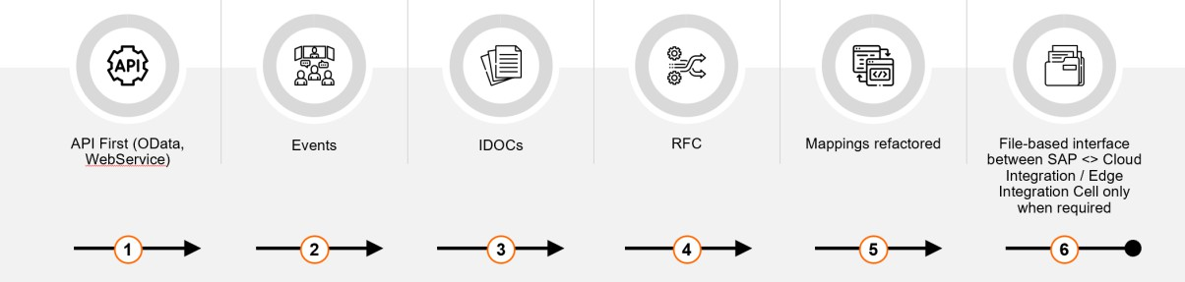
    - The goal is to minimize disruption to sender and receiver applications

API Management
Crave recommend to implement SAP API Management within the BTP Integration Suite to provide Merck Group with a secure, governed, and scalable framework for managing all enterprise APIs.
This setup will establish a central API gateway for SAP and non-SAP systems, enabling controlled exposure of services using OAuth 2.0, JWT, and mTLS authentication.
Standardized policies for security, throttling, transformation, and monitoring will be applied consistently across all interfaces.
A Developer Portal will support cataloging, documentation, and onboarding of internal consumers, while Cloud ALM integration will deliver unified visibility and alerting.
This approach enhances security, agility, and governance, ensuring Merck Group’s integration landscape is API-first and future-ready for S/4HANA and hybrid cloud operations.
Gain flexibility to compose and innovate processes with API-managed integration Central governance for any REST API
➢ Secure REST APIs on any level

- Create digital products and monetize their usage
- Publish APIs in a low-touch approach
- Analyze technical API usage and API trends

- Speed up with templates and API metadata











Event-based integration with SAP Integration Suite
Crave recommends to enable SAP Event Mesh to support Merck Group’s transition toward an event-driven integration architecture. Event Mesh will facilitate real-time, asynchronous communication between SAP and non-SAP systems through event publishing and subscription, reducing dependency on point-to-point interfaces.
Event Mesh will be implemented on a readiness basis, activated only if identified as necessary during integration design. Crave will configure the foundational connectivity and framework under the current scope.
Crave can deliver full implementation under Time & Materials (T&M) upon mutual agreement. Our team will design and configure topics, queues, and subscriptions aligned with business scenarios, ensuring scalability, reliability, and seamless integration with BTP Integration Suite and Cloud ALM monitoring.
Typical Event Mesh use case
    - Business applications expose events, such as when a sales order gets created or changed in SAP S/4HANA Cloud
    - The event is associated with a topic to achieve publish-subscribe (pub-sub) model
    - Sender and receiver(s) are decoupled
    - Standard protocols are used (AMQP 1.0, webhook, REST, Kafka, MQTT)

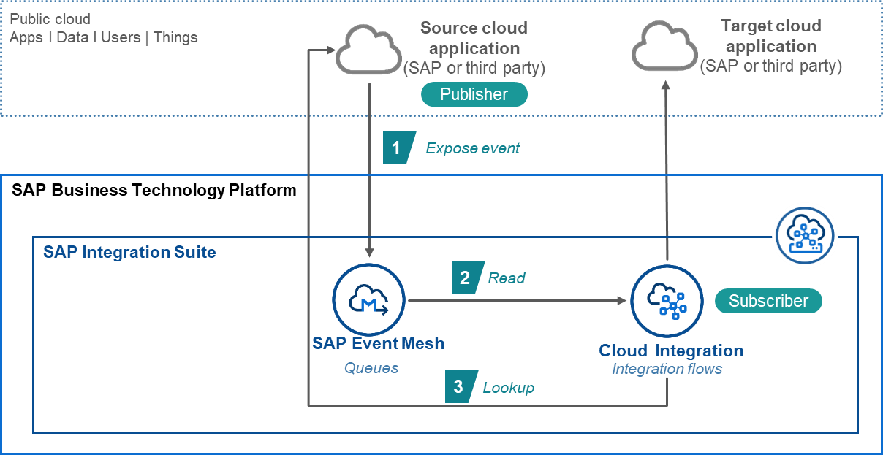

With event-driven extensions for SAP S/4HANA, application extensions can react to events from SAP S/4HANA

Cloud ALM Implementation for Monitoring
Crave recommend to implement SAP Cloud ALM to provide centralized, real-time monitoring and alerting across Merck Group’s new BTP Integration Suite landscape, including the Edge Integration Cell (EIC) and connected SAP/on- premise systems.
This solution will establish an integrated monitoring framework to track interface performance, message flow, latency, and exceptions while enabling proactive alerting, analytics, and SLA management. Cloud ALM will serve as the single operational cockpit for integration visibility, supporting both IT and business teams.
Our implementation will include:
    - System connectivity between Integration Suite, EIC, and Cloud ALM.
    - Configuration of alert rules for failed messages, delays, and throughput thresholds.
    - Custom dashboards displaying message volumes, processing times, and error trends.
    - Integration with Merck Group’s ITSM channels (email, Teams, or
ServiceNow) for automated incident notifications.
    - Knowledge transfer and runbooks to operationalize ongoing monitoring and maintenance.
The resulting framework ensures end-to-end observability, faster incident response, and a sustainable post-migration operations model, aligning with Merck Group’s cloud governance and reliability objectives.

Implementation Approach & Timelines

Crave InfoTech's migration methodology has been incorporated with multiple implementation experiences. Our methodology is based on lean principles and adapts to implementation needs. We have delivered multiple BTP projects successfully with this approach.
Migration Methodology from Boomi / SAP PIPO to Integration Suite
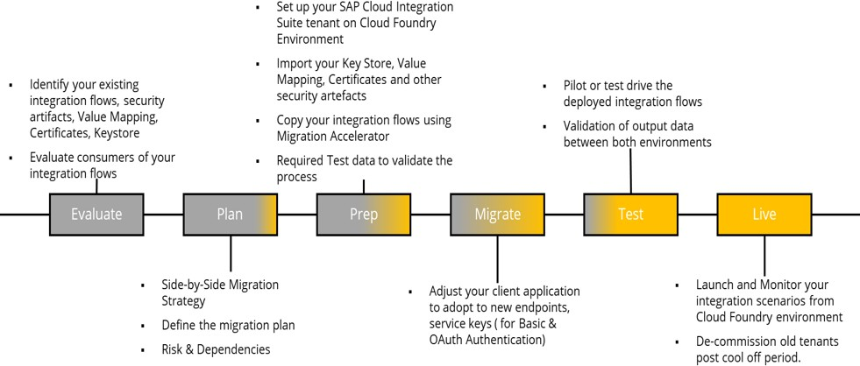
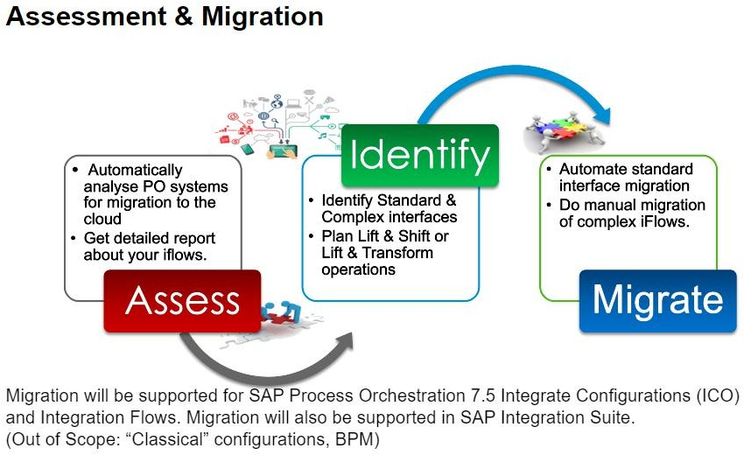

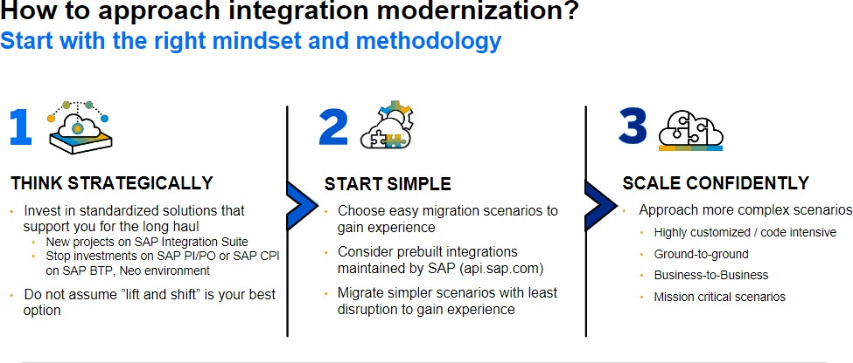
Proposed Timeline:
The proposed timelines represent Crave InfoTech’s structured approach for the
Integration Modernization and Migration Program for MerckGroup.
This engagement will be executed under a Time & Material (T&M) model, ensuring flexibility to accommodate evolving priorities, interface complexities, and phased migration waves across global business units.

Stream | Scope | Estimated Duration | Delivery Model
Boomi to Integrations Migration | Migration and proposed modernization of existing Boomi integrations to SAP Integration Suite | 22 Months | Time & Material
SAP PI/PO to Integration Suite Migration | End-to-end migration of SAP PI/PO integrations, including ICOs, message mappings, routing logic, and adapters, to SAP Integration Suite. | 36 Months | Time & Material

Responsibility Matrix

The definition of the responsibilities of the team members in the delivery organization including Crave InfoTech and Client Organization is critical to the project's success. Proposed Responsibility Matrix will be applicable for Each Wave
/ integration.

Project Phases | Merck | Crave | Remarks
Requirement Gathering | C | R | -
Providing Access to system | R | C | Merck to provide access to the systems and if needed, clarify open points
Configuration and Setup | C | R | Merck to support in giving relevant access
Design | R | C | Merck to review design artefacts
Development & Build | I | R | -
Migration and UT | R | R | To be reviewed by Merck. Pre- requisites for UT (Payload/Files of the interfaces)
SIT | I | R | Merck is responsible for Functional/technical team testing
UAT | R | A | Test scenarios & scripts to be prepared by Merck
Go-Live | R | C | Merck is responsible for Infrastructure support
Hypercare | C | R | -

R – Responsible | A – Accountable | C – Consulted | I – Informed

Merck Group Team
- Executive Sponsor
- Project Owner/Project Coordinator(same or different roles)
- Technical Team
- Business User

Crave Team

Role | Responsibilities | Location
Project Coordinator | - Escalation point for all issues  - Ensure contract carries out according to agreed terms | Onshore/ Offshore
Delivery Manager | - Coordinate and manages end-to-end migration  - Plan development and migration schedule, oversee project including resource management, work allocation and tracking of project schedule and deliverables  - Schedule and presents daily/weekly status calls  - Act as first-level escalation point for all issues | Offshore
Integration Architect | - Analyze the current landscape and design target landscape on Integration suite, Event Mesh, Cloud ALM, EIC  - Define, design and implement iflow templates  - Guide developers and review deliverables  - Address migration issues | Onshore
Lead Developer | - Collaborate with Architect on landscape analysis and design  - Define, design and implement Iiflow templates  - Coordinate with customer team for access provisioning and BTP setup  - Lead technical discussions and collaborate to resolve technical challenges  - Guide developers and review deliverables with Quality consultant | Offshore
Developer | - Migration of PO and development of CPI  - Perform unit testing on migrated CPI  - Handle deployment | Offshore
Quality Consultant | - Ensure testing and quality of the migrated interfaces  - Conduct thorough unit testing and integration testing  - Provide test results of the solution  - Prepare related document | Offshore
Business Analyst | - Conduct detailed discovery sessions to capture functional and compliance needs.  - Validate requirements  - Evaluate change requests | Onshore

SLAs and Service Credits

Crave InfoTech will deliver the Integration Suite migration and related development services under a Time & Materials (T&M) engagement model. The focus of Service Levels and Key Performance Indicators (KPIs) will be on productivity, quality, agility, and customer satisfaction, ensuring predictable delivery and value realization for Merck Group. Governance will be anchored around measurable metrics aligned with sprint deliverables, throughput, and responsiveness.

Service Level Framework
Under the T&M model, Crave will operate within an Agile delivery framework, defining Service Levels around key dimensions of responsiveness, delivery quality, and adherence to planned milestones. Metrics will be tracked and reported weekly and monthly through the Crave Governance Dashboard and SAP Cloud ALM integration.

Service Area | Service Level Objective (SLO) | Target / Commitment
Resource Availability | Ensure planned resource allocation and continuity per approved T&M plan | ≥ 95% resource continuity  per quarter
Sprint Adherence | Delivery of sprint stories and committed items within sprint cycle | ≥ 90% adherence to sprint  commitments
Deliverable Acceptance Rate | Deliverables accepted by Merck without rework or resubmission | ≥ 95% acceptance on first  submission
Defect Density | Number of defects identified per 100 function points delivered | < 2 defects per 100 FP
Defect Resolution Time | Resolution of UAT / QA defects raised by Merck | Critical: < 1 day | Major: < 3 days | Minor: < 5 days
Code Quality Compliance | Code compliance with development guidelines and quality standards  (SonarQube / peer review) | ≥ 98% compliance
Change Request Turnaround | Effort estimation and acceptance within defined timelines | < 2 business days from CR submission
Customer Communication | Response time to Merck’s  functional/technical queries | < 4 business hours average response time

Key Performance Indicators (KPIs)
KPIs for T&M-based development and delivery will be measured monthly and reported as part of the project governance cadence. These KPIs help track delivery efficiency, quality, and customer satisfaction.
  - Migration Progress (%) – proportion of interfaces assessed, converted, validated, and deployed per wave.
  - On-Time Wave Completion – adherence to planned migration wave timelines (≥ 95%).
  - Team Stability Index – measure of resource continuity and ramp-up adherence.
  - Defect Leakage – defects found post-UAT compared to total QA defects (<2%).
  - Customer Satisfaction (CSAT) – stakeholder feedback for quality and responsiveness (≥
4/5).
  - Knowledge Transfer Efficiency – completion and approval of KT sessions/documentation (100% compliance).

Service Credit Framework
The Service Credit mechanism serves as a fair-value performance assurance framework that incentivizes proactive management and timely resolution of issues. Service Credits are calculated when agreed Service Level Objectives (SLOs) are not achieved within a given month. The credits are applied as reductions against the monthly T&M invoice or as equivalent effort credits in subsequent billing cycles.
Service Area | SLA / KPI  Threshold | Credit Trigger | Credit Value
Wave Adherence | ≥ 90% adherence to  sprint commitments | If adherence drops below 90% in a monthly review | 1% of monthly T&M value
Deliverable Acceptance Rate | ≥ 95% first-time acceptance | If first-time  acceptance falls below 95% | 1% of monthly T&M value
Defect Resolution Time | Critical < 1 day; Major < 3 days | If >10% of defects exceed resolution SLA | 1% of monthly T&M value
Defect Density | < 2 defects per 100 Artefacts | If defect density exceeds 2 per 100  Artefacts | 0.5% of monthly T&M value
Customer Response Time | < 4 business hours | If average response exceeds 6 hours | 0.5% of monthly T&M value

Exclusions
Service Credits will not apply in cases where performance deviations are caused by factors beyond Crave InfoTech’s reasonable control, including but not limited to: delays in client feedback or approvals, changes in scope, third-party dependencies, infrastructure failures, or force majeure events. Service Credits are intended as a performance safeguard and not as a form of penalty or liquidated damages.

Change Management

It may become necessary to amend this SOW based on changes in the Client’s requirements or other factors leading to the change in the scope. In the event either party desires to change this SOW, the following procedures will apply:
- The party requesting the change will deliver a Change Request Form to the other party. The Change Request will describe the nature of the change, the reason for the change, and the effect the change will have on the scope of work, which may include changes to the Deliverables, the schedule and the price.
- A Change Request may be initiated by either party for any changes to the SOW. The designated contact of the requesting party will review the proposed change with his/her counterpart. The parties will evaluate the Change Request and negotiate in good faith the changes to the Services and the additional charges, if any, required to implement the Change Request. If both parties agree to implement the Change Request, the appropriate authorized representatives of the parties will sign the Change Request, indicating the acceptance of the changes by the parties.
- Upon execution of the Change Request, said Change Request will be incorporated into, and made a part of, this SOW.

Commercials

Development effort estimates calculation

We have used following estimates based upon the complexity of the interfaces for the calculation of migration/development efforts. These complexities might differ from what is mentioned in RFP. We have adjusted the complexities to align with our effort estimation.

Boomi
Non GxP | 411
GxP | 40
Electronic | 366
Total | 817

Small | ROM in Days | Man Days |  | Medium | ROM in Days | Man Days |  | Large | ROM in Days | Man Days
74 | 2 | 148 |  | 96 | 3 | 288 |  | 241 | 4 | 964
21 | 2 | 42 |  | 2 | 3 | 6 |  | 17 | 5 | 85
5 | 2 | 10 |  | 78 | 3 | 234 |  | 283 | 4.5 | 1273.5
 |  | 200 |  |  |  | 528 |  |  |  | 2322.5 | 3050.5
Total development man days for BOOMI migration = 3050.5

PIPO
515

Small | ROM in Days | Man Days |  | Medium | ROM in Days | Man Days |  | Large | ROM in Days | Man Days
261 | 1 | 261 |  | 158 | 2 | 316 |  | 96 | 4 | 384
 |  | 261 |  |  |  | 316 |  |  |  | 384 | 961
Total development man days for PI/PO migration = 961
Note: We will achieve these optimized hours using Crave Integration Workbench (CIW) migration tool. There is potential to reduce the Boomi migration time further which we can only quantify during the realization phase.

In addition, we will have shared Project coordinator and Stakeholder Manager common for both the streams.
We will have Business Analyst/QA who will be responsible for the information gathering, coordination between different parties within Merck group and testing.

Resource Schedule, Rates and Estimated Cost:
PI-PO Migration:

Sr.  No. | Crave Resources | Location | Resource Count | Band | Month-01 | Month-02 | Month-03 | Month-04 | Month-05 | Month-06 | Month-07 | Month-08 | Month-09 | Month-10 | Month-11 | Month-12 | Month-13 | Month-14 | Month-15 | Month-16 | Month-17 | Month-18 | Month-19 | Month-20 | Month-21 | Month-22 | Month-23 | Month-24 | Month-25 | Month-26 | Month-27 | Month-28 | Month-29 | Month-30 | Month-31 | Month-32 | Month-33 | Month-34 | Month-35 | Month-36 | Man Days | Per hour Rate in USD | Total Cost
1 | Integration Architect | Offshore | 1 | L1 | 1 | 1 | 1 | 1 | 1 | 1 | 1 | 1 | 1 | 1 | 1 | 1 | 1 | 1 | 1 | 1 | 1 | 1 | 1 | 1 | 1 | 1 | 1 | 1 | 1 | 1 | 1 | 1 | 1 | 1 | 1 | 1 | 1 | 1 | 1 | 1 | 792 | $ 60 | $ 427,680
2 | Integration Developer (Bangalore) | Offshore | 1 | L2 | 1 | 1 | 1 | 1 | 1 | 1 | 1 | 1 | 1 | 1 | 1 | 1 | 1 | 1 | 1 | 1 | 1 | 1 | 1 | 1 | 1 | 1 | 1 | 1 | 1 | 1 | 1 | 1 | 1 | 1 | 1 | 1 | 1 | 1 | 1 | 1 | 792 | $ 50 | $ 356,400
3 | Integration Developer | Offshore | 1 | L3 | 1 | 1 | 1 | 1 | 1 | 1 | 1 | 1 | 1 | 1 | 1 | 1 | 1 | 1 | 1 | 1 | 1 | 1 | 1 | 1 | 1 | 1 | 1 | 1 | 1 | 1 | 1 | 1 | 1 | 1 | 1 | 1 | 1 | 1 | 1 | 1 | 792 | $ 45 | $ 320,760
4 | Business Analyst / QA | Offshore | 1 | L2 | 2 | 2 | 2 | 2 | 2 | 2 | 2 | 2 | 2 | 2 | 2 | 2 | 2 | 2 | 2 | 2 | 2 | 2 | 2 | 2 | 2 | 2 | 2 | 2 | 2 | 2 | 2 | 2 | 2 | 2 | 2 | 2 | 2 | 2 | 2 | 2 | 1584 | $ 50 | $ 712,800
5 | Project Co-ordinator (Bangalore) | Offshore | 1 | L1 | 0.5 | 0.5 | 0.5 | 0.5 | 0.5 | 0.5 | 0.5 | 0.5 | 0.5 | 0.5 | 0.5 | 0.5 | 0.5 | 0.5 | 0.5 | 0.5 | 0.5 | 0.5 | 0.5 | 0.5 | 0.5 | 0.5 | 0.5 | 1.0 | 1.0 | 1.0 | 1.0 | 1.0 | 1.0 | 1.0 | 1.0 | 1.0 | 1.0 | 1.0 | 1.0 | 1.0 | 539 | $ 60 | $ 291,060
7 | Stakeholder Manager (Germany) | Onshore | 1 | L1 | 0.5 | 0.5 | 0.5 | 0.5 | 0.5 | 0.5 | 0.5 | 0.5 | 0.5 | 0.5 | 0.5 | 0.5 | 0.5 | 0.5 | 0.5 | 0.5 | 0.5 | 0.5 | 0.5 | 0.5 | 0.5 | 0.5 | 1.0 | 1.0 | 1.0 | 1.0 | 1.0 | 1.0 | 1.0 | 1.0 | 1.0 | 1.0 | 1.0 | 1.0 | 1.0 | 1.0 | 550 | $ 200 | $ 990,000
Crave | Resource Count / Week |  |  |  | 6.0 | 6.0 | 6.0 | 6.0 | 6.0 | 6.0 | 6.0 | 6.0 | 6.0 | 6.0 | 6.0 | 6.0 | 6.0 | 6.0 | 6.0 | 6.0 | 6.0 | 6.0 | 6.0 | 6.0 | 6.0 | 6.0 | 6.5 | 7.0 | 7.0 | 7.0 | 7.0 | 7.0 | 7.0 | 7.0 | 7.0 | 7.0 | 7.0 | 7.0 | 7.0 | 7.0 | 5049 | $ 68 | $ 3,098,700.00

Boomi Migration:

No. | Crave Resources | Location | Resource Count | Band | Month-01 | Month-02 | Month-03 | Month-04 | Month-05 |  | Month-07 | Month-08 | Month-09 | Month-10 | Month-11 | Month-12 | Month-13 | Month-14 | Month-15 | Month-16 | Month-17 | Month-18 | Month-19 | Month-20 | Month-21 | Month-22 | Month-23 | Month-24 | Month-25 | Month-26 | Month-27 | Month-28 | Month-29 | Month-30 | Month-31 | Month-32 | Month-33 | Month-34 | Month-35 | Month-36 | Man Days | Per hour Rate in USD | Total Cost
1 | Boomi/SAP Integration Architect | Offshore | 3 | L1 | 1 | 1 | 1 | 1 | 1 | 1 | 1 | 1 | 1 | 1 | 1 | 1 | 1 | 1 | 1 | 1 | 1 | 1 | 1 | 1 | 1 | 1 |  |  |  |  |  |  |  |  |  |  |  |  |  |  |  |  | $
2 | Integration Developer (Bangalore) | Offshore | 3 | L2 | 1 | 1 | 1 | 1 | 1 | 1 | 1 | 1 | 1 | 1 | 1 | 1 | 1 | 1 | 1 | 1 | 1 | 1 | 1 | 1 | 1 | 1 |  |  |  |  |  |  |  |  |  |  |  |  |  |  |  | $ | $
3 | Integration Developer | Offshore | 3 | L3 | 3 | 3 | 3 | 3 | 3 | 3 | 3 | 3 | 3 | 3 | 3 | 3 | 3 | 3 | 3 | 3 | 3 | 3 | 3 | 3 | 3 | 3 |  |  |  |  |  |  |  |  |  |  |  |  |  |  |  | $ | $
4 | Business Analyst / QA | Offshore | 2 | L2 | 3 | 3 | 3 | 3 | 3 | 3 | 3 | 3 | 3 | 3 | 3 | 3 | 3 | 3 | 3 | 3 | 3 | 3 | 3 | 3 | 3 | 3 |  |  |  |  |  |  |  |  |  |  |  |  |  |  |  | $ | $
5 | Project Co-ordinator (Bangalore) | Offshore | 1 | L1 | 0.5 | 0.5 | 0.5 | 0.5 | 0.5 | 0.5 | 0.5 | 0.5 | 0.5 | 0.5 | 0.5 | 0.5 | 0.5 | 0.5 | 0.5 | 0.5 | 0.5 | 0.5 | 0.5 | 0.5 | 0.5 | 0.5 |  |  |  |  |  |  |  |  |  |  |  |  |  |  |  | $ | $
6 | Stakeholder Manager (Germany) | Onshore | 1 | L1 | 0.5 | 0.5 | 0.5 | 0.5 | 0.5 | 0.5 | 0.5 | 0.5 | 0.5 | 0.5 | 0.5 | 0.5 | 0.5 | 0.5 | 0.5 | 0.5 | 0.5 | 0.5 | 0.5 | 0.5 | 0.5 | 0.5 |  |  |  |  |  |  |  |  |  |  |  |  |  |  |  | $ | $
3 | Integration Developer | Offshore | 3 | L4 | 3 | 3 | 3 | 3 | 3 | 3 | 3 | 3 | 3 | 3 | 3 | 3 | 3 | 3 | 3 | 3 | 3 | 3 | 3 | 3 | 3 | 3 |  |  |  |  |  |  |  |  |  |  |  |  |  |  |  | $ | $
Crave | Resource Count / Week |  |  |  | 12.0 | 12.0 | 12.0 | 12.0 | 12.0 | 12.0 | 12.0 | 12.0 | 12.0 | 12.0 | 12.0 | 12.0 | 12.0 | 12.0 | 12.0 | 12.0 | 12.0 | 12.0 | 12.0 | 12.0 | 12.0 | 12.0 | 0.0 | 0.0 | 0.0 | 0.0 | 0.0 | 0.0 | 0.0 | 0.0 | 0.0 | 0.0 | 0.0 | 0.0 | 0.0 | 0.0 |  | $ | $

Currently we have given the T&M proposal for 36-month PI-PO migration as requested in the RFP. But we believe that we can significantly shorten the PI-PO migration time by reducing the technical migration time using Crave Integration Workbench (CIW) migration tool which has capability to automate the conversion of custom adapters and Java script. In addition, the tool will automate the testing through payload comparison and finally automation of the as built documentation.
The actual duration will be dependent upon the preparation of the Merck group team to expediate the migration.
This can reduce the total cost of the project.

Governance (Meetings/Steercos/Escalation Path)

Communication Plan
Following table represents different reports that will be generated periodically and circulated to various stakeholders.

Exhibit: Daily Interaction
Activity | Communication Mode | Report Recipient/s | Frequency | Comments
Weekly Status Reports | Email | Crave InfoTech Project Coordinatorand Merck Group Project Manager | Weekly | Summarize the tasks delivered & issues from the previous week(s), activities planned for the next week & specific events.  Project Effort and Schedule Variance

Additional meetings will be decided during project planning phase as necessary.

Issue Resolution and Escalation Procedure
Crave InfoTech’s Project Coordinatorwill identify and capture project related issues that adversely impact the project, launch relevant actions to resolve them, and track and monitor the issues to closure. The Crave InfoTech’s Project Coordinatorwill also decide on the appropriate escalations for any critical/unresolved issues.
The responsibilities / timescales for executing these procedures are:

Issue Management
Task | Timescale | Responsibility
Raise Issue Report | As they occur | Any person working on or related to the project
Assessment/ Management of  issues | Weekly/periodically | Crave InfoTech Project Coordinator
Reporting | Periodically | Crave InfoTech Project Coordinator

Following guidelines will be followed for reporting the issues:
- Develop issue report containing problem description and suggested solution. Report to Crave InfoTech Project Manager
- Issues will be documented in issue reports and in the project’s issue log.

- The Crave InfoTech Project Coordinator is responsible for problem classification together with the issue reporter
- The Crave InfoTech Project Coordinator will convey the issue to the issue owner and define actions. If the problem is serious or critical, an issue report will be sent with a meeting invite
- The Crave InfoTech Project Coordinator assigns the action to the issue owner or/and action owner
- The Crave InfoTech Project Coordinator will monitor and follow up the action plan
- The Crave InfoTech Project coordinator will terminate the problem handling process when the problem is solved or decided closed

Following exhibit explains the process of issue classification:

Issue Classification
Problem Type | Definition | Reporting process | Solution Responsible
Low | Implies none or low  project delay and/or cost increase. | Report to Crave InfoTech Project  Manager. Issue handled within the project. | Crave InfoTech Project Manager
Serious | Implies serious project delay and/or cost increase or influence on working  relation. | Report to Crave InfoTech Project Coordinatorand Crave InfoTech Account Executive. Inform Merck Group Project  Coordinatorresponsible | Crave InfoTech Project Manager  Merck Group Project Manager
Critical | Implies critical treat against the project or working relation. | Immediately report to Crave InfoTech Project Manager, Crave InfoTech Account Executive and the member of the Project Core Committee including Merck  Group Project representative | Crave InfoTech Project Manager  Merck Group Project Manager

Following escalation process will be followed as part of the issue management:

Exhibit: Escalation Process
Issue Type | Escalation Point | Escalation Criteria | Governance Role (Project Core Group)
Project Delivery | Crave InfoTech Project Manager | If plan to resolve the issue is not outlined within 48 hrs (24 hrs in case of urgent issues) | Weekly checkpoints (or depending on the urgency)  Issue resolution Quality issues
Contract  Unresolved delivery issue  Program Management  issue within specified timeframe | Crave InfoTech Account Executive | If plan to resolve issue is not outlined within 48 hrs (24 hrs in case of urgent issues) | Monthly Review  As needed in case of urgent issues

**The Project Workgroup will be comprised of representatives from Crave InfoTech and Merck Group key project stakeholder.

SLA Reporting
Service Levels and KPIs will be monitored and governed through a structured governance model including weekly status calls, bi-weekly sprint reviews, and monthly steering committee meetings. Performance dashboards will be shared via CIW
In case of KPI or SLA deviation, Crave will conduct a root cause analysis within 24 hours and implement corrective actions in the subsequent sprint. Continuous improvement initiatives will be logged, tracked, and reviewed jointly with Merck’s project management team.

Service Credit Review
Service Credits will be reviewed during monthly governance meetings and formally validated during quarterly reviews. A consolidated report of Service Credits, deviations, and corrective actions will be shared with Merck Group. Crave will conduct a root cause analysis for each deviation and initiate corrective actions within 24 hours of identification. If any SLA deviation persists for two consecutive months, a focused improvement plan will be jointly developed with Merck.

Continuous Improvement
Crave InfoTech treats the Service Credit mechanism as a continuous improvement driver. Performance trends will be analyzed quarterly to identify systemic improvement opportunities and implement process enhancements that prevent SLA breaches. This proactive governance ensures sustained delivery excellence throughout the engagement lifecycle.

Sign Off

IN WITNESS WHEREOF, Crave InfoTech LLC and Merck Group have each caused this Project Proposal to be executed by their respective duly authorized officers as of the Effective Date.
The undersigned agree to the terms of this proposal on behalf of his or her organization or business.

Merck Group Crave InfoTech LLC

By: By:
Authorized Signature Authorized Signature
Name: Name: Vrushali Nistane

Date: Date:

Appendix

